Question 1: What is the main problem that you are solving?

- Unsupervised Content is the first problem that we tend to solve it as it has a lot of effects on the users especially the younger ones, So the Parents will have the authority to control what their children’s watch.

- Recommendation for Undesired Content is the second problem we tend to improve and increase its accuracy as many platforms depend on many techniques and calculations in their recommendation system but the results may not suit the user’s need especially the cold-start ones.
Question 2: What is the importance of this problem?

It’s a crucial issue as consuming media is becoming essential in everyone’s life specially videos. Sensitive content is sometimes disturbing for viewers especially younger audience and may affect them with mental and psychological illness. Also the system will increase the accuracy of the resulted videos for the audiences and enhance the recommendation system by keeping away just labelled content and recommending object-scanned video which will be more reliable and safe.
Question 3: What are the current solutions?

Currently there are no really a reliable solution for this problem as only indicator for the content inside the video is the rating given for it. In most cases this rating might be inaccurate and uncomfortable for some audiences, this also depends on the video being labelled and receiving implicit feedback which might change from a user’s perspective to another.
Question 4: How will your solution solve the problem? What is new?

By creating a search, filtering and recommendation system for videos which will analyse the content inside the video. The content will be analyses based on objects found in the video, these objects will be labelled. Labels are used as attributes for recommending and searching instead relying on calculations, user’s watch history data and direct feedback. Calculations based on user’s data are used by almost every video platform which makes our proposed solution unique and reliable enough to solve this problem.
Question 5: What is the expected impact of your solution from various perspectives (social, commercial, environmental, etc.)?

The expected result is having a clean watching experience for audience of all age groups, also introducing the video search function which will revolutionize how users search for their videos.

Commercially this will enhance companies search engines (think google search with image), introducing a new way of searching through huge databases of videos. This will upgrade the company’s offerings by using this search engine as a service

Question 6: Give a high level functional description of your solution. How will it be used?
Simply a video (short clip) will be used as input either automatically generated from highlights or inserted by the user, results will appear in form of recommended videos, or search result from the manually or automatically inserted video. Video data are detected using object detection forming a table of data. This table of data is used to compare other video with their table of data. By similarity measurements relevance is calculated for the videos, video with highest similarity should appear first.
Then the second feature comes where a list of objects that the user doesn’t want to appear during media consumption, these objects will be detected and removed(blocked) before appearing on screen for safe and clean watching experience.
Question 7: Give a high level technical description of your solution: architecture, technology, integration, innovative components, etc.

This project focuses on proposing a new challenge for recommending videos based on their visual features (i.e., content). The proposed system implements a new function for searching by a scene just like a normal search engine. It aims to find similar content from video and output as a search result. Also, a great challenge is introducing a way to block certain scenes based on the user's custom-built filter, to achieve a clean watching experience.
The proposed system overview is shown in the figure below. It consists of three main phases. In the first phase, the user can start watching videos normally. The input scene will be selected from the highlights of the video or the user can select a specific interval form the current video to use as a search query. A video will be imported to be processed in the second phase either from the search or from the highlights. During the second phase, object detection can take place. After processing has occurred, a frequency table for objects has been generated. This table is used to compare the content of the video to the database videos which also has the table of data given. By similarity measurements throughout the third phase, results should appear in the form of recommended videos based on highlights from the input video, or in a form of search result, from the user's input. It is also possible to have some scenes filtered and removed from the video based on a filtering created by the user to remove a certain content.

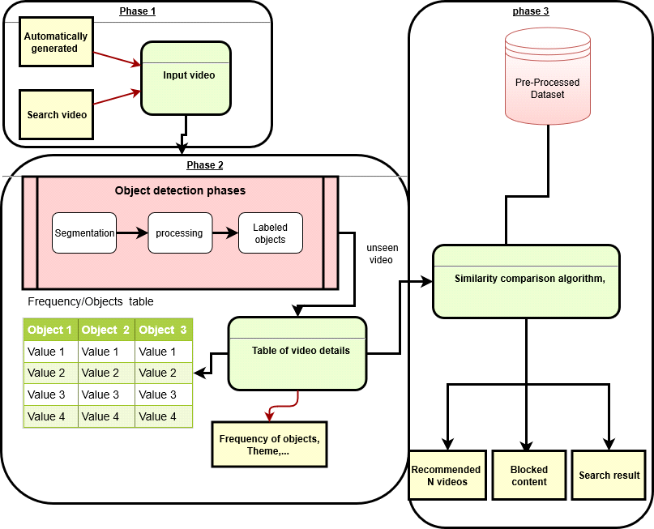

Question 8: Give a high level description of your solution development environment, platform, tools, etc.

-The Platform: the system will be an extension on web browsers.
-Development environment: python programming language will be used to compile code for detecting objects and PostgreSQL database to store the data of the system and Yolo system to detect object accurately.
-Tools: Google colaboratory will be used for training and testing of the dataset.

Question 9: How will you manage your product development cycle, your quality assurance process, your solution deployment logistics, etc.?
During the development lifecycle the code will run several tests first we need to make sure the sample of objects are trained with high accuracy to ensure relevant table of data which will enhance the results, testing this accuracy will be used by tools like Rapid miner, which displays accuracy of classifiers and object detectors. also this system need to be secured, the required security measurement is only for the table of data, as the video is mostly available for public.
Quality assurance will be testing vs the current famous algorithm which is a recommendation system by using collaborative filtering, then this could be deployed to a streaming platform to get real life results then use this platform later as a potential customer.

Question 10: Give the most relevant plans that you have developed for your project (for example, time schedule, resource plan, training plan, risk management, contingency plan, etc.)

