DELL Technologies Envision the Future Competition 2019-20 (Palm Disease Detection)
1. Refined Project Description:
1.1 The problem and its importance:
Palms are one of the best known and most widely planted tree families. They are considered of great importance to the agricultural economy of many countries, especially in the Middle East. Egypt, which is our main concern owns nearly 15.5 million palm trees and considered to be the largest date producer worldwide with a date production of 1,373.57 thousand Metric Tonnes in 2017 (Dargham, 2019). Despite these facts, palms are threatened by two common diseases (Leaf spots, blight spots) and a lethal pest called Red Palm Weevil, a worldwide infestation problem as it affects 17 palm species in 35 countries. RPW can severely damage the palm by hiding inside its texture resulting in the invisibility of its symptoms to the naked eyes during the early stages of infection and it only appears when the palm is nearly dead and untreatable.
1.2 Project scope and expected outcome:
The project will result in an android mobile application with a Real-time detection of leaf spots and blight spots diseases by mobile cameras and also Red Palm Weevil detection by acquiring thermal images of palm trees using thermal USB camera connected to smartphones. These images will be enhanced, then machine learning techniques will be applied to them in order to early detect these diseases before the palm reaches an untreatable state.
1.3 Adjustments:
We are running our model on Google cloud instead of Amazon web service (AWS) due to two main reasons, first is cost as Google environment was found to be 28% less than AWS in cost. Second is latency where Google was the winner as well (Jackson, 2020).
2. Refined Project Plan:
2.1 Detailed schedule and milestones:
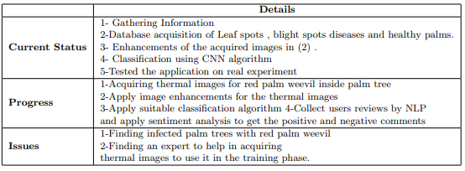
2.2 Team structure:
- Android Developer: Translate design into high quality code, responsible for quality, performance and responsiveness of the application.
- Software Engineer: Collects requirements, prepare project documentation and generates maintainable software design in case a change by stakeholders or user requirements is needed.
- Data Scientist: Uses machine learning algorithms to implement models in Python to improve software performance. Responsible also for manipulation of acquired images.
- Database Administrator: Creates database design, monitors users access, controls access permissions and privileges.
2.3 Contingency and risk mitigation plan
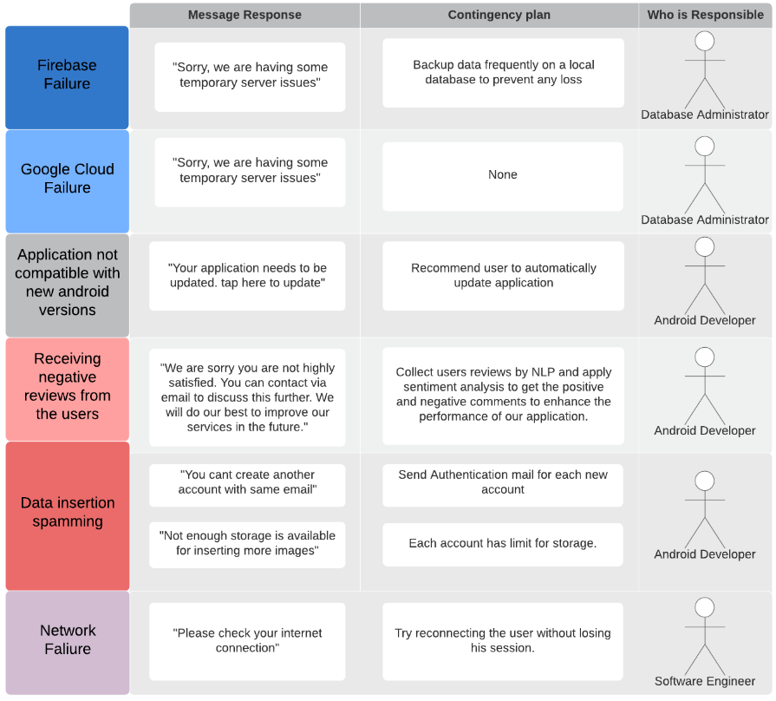
3. System Requirements:
Our main process while dealing with customer requirements are Analyze, Design, Implement and evaluate.
3.1 Requirements Elicitation process:
Requirements Elicitation:
- Frequent stakeholders’ meetings taking into consideration the time and availability of stakeholders.
- Sometimes if there is any urgent information, we usually contact our stakeholders via emails.
- Requirements are gathered as user stories and user cases which are written on a white board to facilitate planning.
Requirements Analysis:
- Evaluate the feasibility of requirements.
- Perform technical analysis on the requirements together with the constraints and conditions associated with it.
Requirements prioritization: Prioritization is done in collaboration with the stakeholders.
- Requirements were divided into: 1. ought to be part of the project 2. Found outside scope.
- For the requirements that are deemed to be within project scope, determining which ones are more important than others was needed so that their implementation can be done first in the project.
- Numerically ranking these requirements according to their importance; a small value means a low priority while a large value indicates a high priority.
Change management:
- Stakeholders’ feedback was gained on different prototype versions as early as possible so that we don’t sacrifice time and effort.
- User stories were used to describe user goals and clarify the output for them.
- Several design patterns were used to facilitate any modification without changing the whole structure of the code.
Challenges encountered:
Some of the agriculture terms were very ambiguous to our team and gaining information about palm trees and its diseases were an obstacle at the beginning, but later on we learned more about these terms and get used to it.
List of stakeholders, user and clients:
1. Companies: 1.1. National Authority for Remote Sensing & Space Sciences
1.2. Palm research center
2. Farms: 2.1. Farm in AlFayoum, Egypt
2.2. Farm in AlMansouria, Giza, Egypt
3.2 System Requirements List:
Functional Requirements:
3.2.1.User:
3.2.1. User can signUp/signIn to use the application.
3.2.2. User can edit his profile.
3.2. Palm Owner:
3.2.1. Palm Owner can add, edit, delete and show palm tree.
3.2.2. Palm Owner can show his palm trees.
3.2.3. Palm Owner can attach images to his palm trees.
3.2.4. Palm Owner can detach images of his palm trees.
3.2.5. Palm Owner can request diagnosing an image and show the results.
3.2.6. Palm Owner can choose to save classifier results.
3.2.7. Palm owner can choose to diagnose full palm, leaves, trunk and palm Base.
3.3. Admin:
3.3.1. Admin can show and update all users’ information registered to the system.
3.3.2. Admin can unregister users from the system.
3.3.3. Admin can show, edit, delete permissions attached to each user type.
4. Expert:
3.4.1. Expert can show all palms.
3.4.2. Expert can show all palms’ results.
3.4.3. Expert can correct palms’ results.
Non-Functional Requirements:
- Maintainability: The system is maintained through using list of design patterns (MVC, Single Tone, Decorator, Strategy).
- Usability: The system will be user friendly and straight forward as palm owner may not be familiar with modern technologies, that is achieved through the following:

A Mobile Application that is:
1. User friendly 2. Multilanguage 3. Easy sequential capture image method.

Applying Nelson usability heuristics methods:
1. visibility of system status. 2. matching between system and real world. 3. user control and freedom. 4. consistency and standards. 5. Error prevention. 6. Help user recognize diagnose and recover from errors.
- Reliability: 1. The system operations can be restored through adding Boolean is-deleted column in all database tables, once a delete operation is executed the only change in database row will be the is-deleted value. 2. The system uses real time database through connecting to Firebase. 3. The system uses google cloud for model training to provide a classification for the infection level of infestation through the model’s high accuracies achieved.
- Resource Utilization: 1. Every piece of text that a user might see can be modified without changing in code. 2. Most of computations are made on the server not on the smartphone due to the leak of smartphone utilities in handling all needed computations.
4. System Design:
4.1 System Architecture:
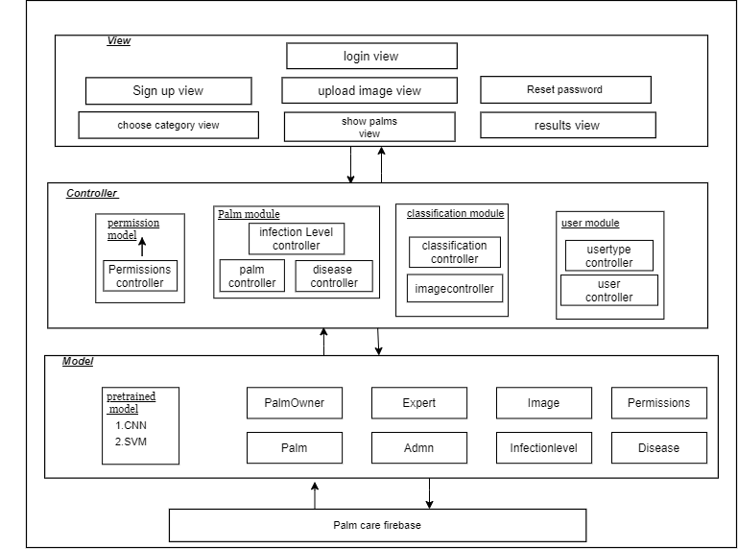
4.2 User interface:
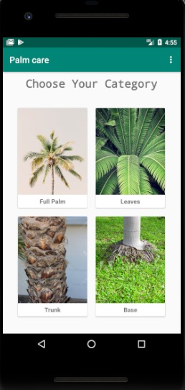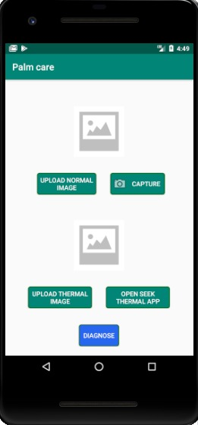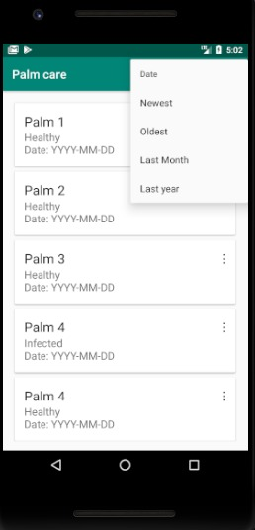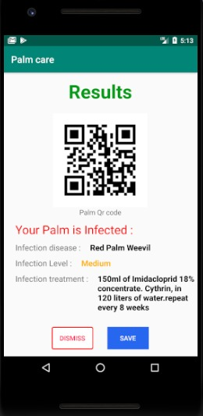
4.3 Algorithmic components:
- Convolutional neural network (CNN).
- Support Vector Machine (SVM).
4.4 Innovative aspects of the design:
Our application is the first app to detect palm trees diseases as well as red palm weevil through using thermal camera. The user can choose which part of the palm tree he would like to take an image for it (Full palm tree, Trunk, base, Leaves), this will save processing time. The user is going to choose which type of image he is going to deal with, the application will recommend him to take the palm image using both thermal and normal images for better results. The application can also generate and read QR code used as an identifier for each palm. The application will show the results if the palm is infected or not, and infection level in case of palm infection, also the application will provide some solutions to the user according to the infection level. Palm information and results will be saved to the user account and the user can show them at any time.
5. System Implementation:
5.1 Hardware and software platforms:
Hardware platform:
- Android Mobile with at least android 5.0
- Normal mobile camera, minimum 8 megapixel.
- FLIR one pro USB thermal camera.
Software Platform: Android Operating System
5.2 Hardware and software development tools and languages:
Development Tools:
- Android studio for the development of the mobile application.
- Jupiter notebook IDE to implement our AI model for prediction.
Languages:
- Python 3 is used in the Jupiter IDE.
- Java 8 used in android.
5.3 Components acquired from external sources:
- Python library called Matplotlib as we use the component Pyplot to plot graphs and area to see the performance of our code.
- Keras library to implement the CNN deep learning algorithm.
- VGG16 which is pre-built in keras model used to improve the results accuracy.
- Flask API which connect our android application with Python
5.4 Innovative aspects of the implementation:
CNN Model upon Keras neural-network library which is well known for its high performance with hard classification computations and its capability of increasing the efficiency and accuracy of the model when dealing with huge datasets. Our CNN model is built on pre-structured VGG16 Network that’s known for its well measured layers and parameters. We made our customizations in some layers in the VGG16 architecture to fit our palm disease classification case and added some features to the code that makes it computationally inexpensive, efficiently extracting features and predicting the outcomes in a maximum accuracy depending on the variation and the size of the given dataset.
6. Other issues and challenges:
One challenge was that we intended to use drone cameras to facilitate taking shots of huge palm areas which will save a lot of time, but unfortunately this was hard due to country security reasons. Also, we tried to use satellite hyperspectral cameras which was going to be very useful as it can detect indices for assessing damage by the red palm weevil to palm trees, but we realized from experts in NARSS (National Authority for Remote Sensing Space Sciences) that it is something hard to achieve as it requires a lot of time and knowledge to deal with these satellites, and we don’t have enough of it at the moment.

References
Dargham, D. (2019, 3 18). TOP 10 DATE PRODUCING COUNTRIES IN THE WORLD. Retrieved from Embassy of Egypt Economic and Commercial Office in Brazil: https://ecob.com.br/top-10-date-producing-countries-in-the-world/
Jackson, B. (2020, 1 1). Google Cloud vs AWS in 2020 (Comparing the Giants). Retrieved from Kinsta: https://kinsta.com/blog/google-cloud-vs-aws/#storage

