Marker-less AR-Drive: Object detection for marking with Markerless Augmented reality abnormal behavior trucks
Andrew Albert,Ahmed ElKoddosi,Soha Mahmoud,Mahmoud Mostafa Supervised by Dr. Ayman Ezzat and Eng. Noha ElMasry
September 27,2017

Abstract
A mobile app that takes a video of banknotes while being counted in the counting machine and then this video will be processed to identify the serial number of each paper. The main purpose of having a serial number that each paper has a unique identification. So we propose an app that detect the serial number with OCR (optical character recognition) and then assign banknotes to an owner according to the serial number and by this ,tracking the money and modifying the ownership can be possible.
1 Introduction
1.1 Background
OCR became one of the most usable technologies as many businesses make use of OCR programs and software to hasten their data entry process. As using OCR program reduces human error, which can occur while the data is being input. With OCR, any serial number can be transformed into digital output. It doesn’t take in account the nature of the object as it just after the image is taken, it will be preprocessed and the characters are extracted and recognized. And the aim of preprocessing the image is to improve the chances of a successful recognition after removing unwanted distortions and image features are enhanced. In this project, we will focus on detecting and recognizing the serial in banknotes to assign each one to its owner and giving the capability of changing owners . and if the owner lost the money ,the facility of tracing it back .

1.2 Motivation
Egypt was ranked third in the ranking of the theft index at the level of Arab countries(1). Therefore all forces should focus on minimizing this program to shrink theft problem as its increasing especially in the past few years due to high rise of process with lead to increase in poverty level . so everyone has the right to be capable of tracking their money if lost .

- https://thawrah2day.com/2016/12/06/مصر-المرتبة-الثالثة-عربيا-مؤشر-الجريم/

1.3 Problem Definitions
The challenge is to accurately detect the car making abnormal behavior around the driver when there are multiple vehicles around him. Our aim is to detect abnormal behaviors in realtime with increased GPS accuracy using the smartphone’s front and rear camera. Another challenge is to reduce the delay time in data transmission from and to the server, which mainly occurs because of large data files. The solution is to compress and decompress the data before and after sending and retrieving from the server.

1.3 Problem Definitions

The challenge is to accurately be able to detect and read the serial number characters found on the money bills to track the ownership of the money and be able to check if it’s stolen.
First the money bills serial number is read and associated to the first owner of the bill. So, whenever the owner trades his money with someone else the new owner shall scan the money bills to transfer the ownership of the bills. If such thing didn’t happen the original owner can report that his money is stolen and thus the system tracks every owner of this bill to find out where the money went missing.

2 Project Description

Accurate detection and recognition of the Arabic numerals found on the money bills to track the ownership of this bill and check if it’s stolen.

2.1 Objectives

The system is designed to help the owners of money bills keep ownership of their bills and help them protect what’s theirs. If an owner reported that his money is stolen or went missing, the system backtracks to every owner of the bill to find out where the ownership was falsified or wasn’t transferred. Then the system reports to the police or the responsible entity.

2.2 Scope

2.3 Project Overview

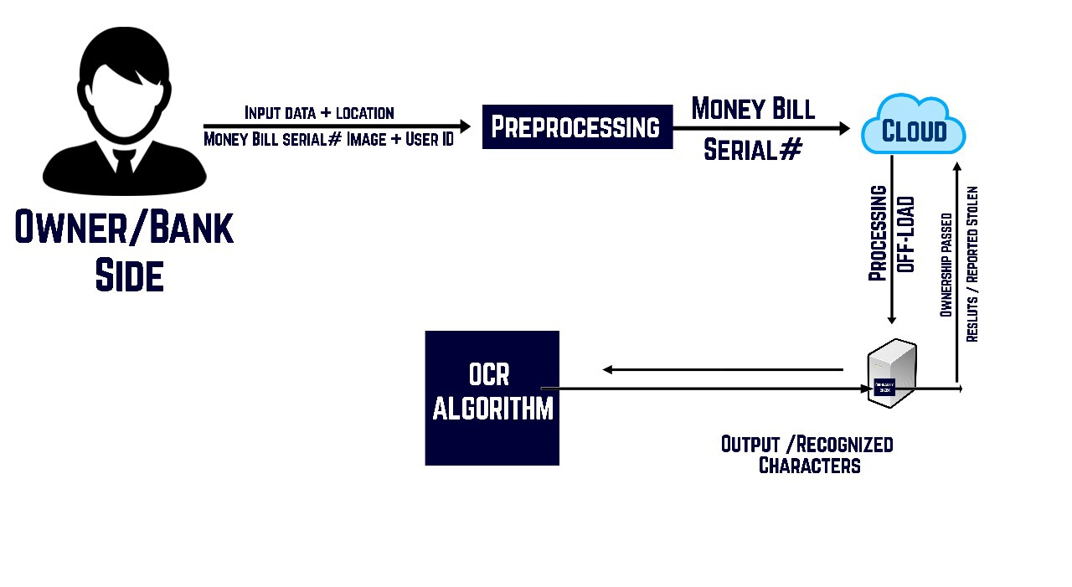
The process of ownership transfer from owner/bank, the application take various inputs (Serial number from money bill, user id, location). save serial number in the cloud after scanning the money bill, then send serial number to the server, server pass serial number to OCR algorithm to recognize & export characters, in the last step originality check in the server to check if the ownership will be passed or it’s reported.
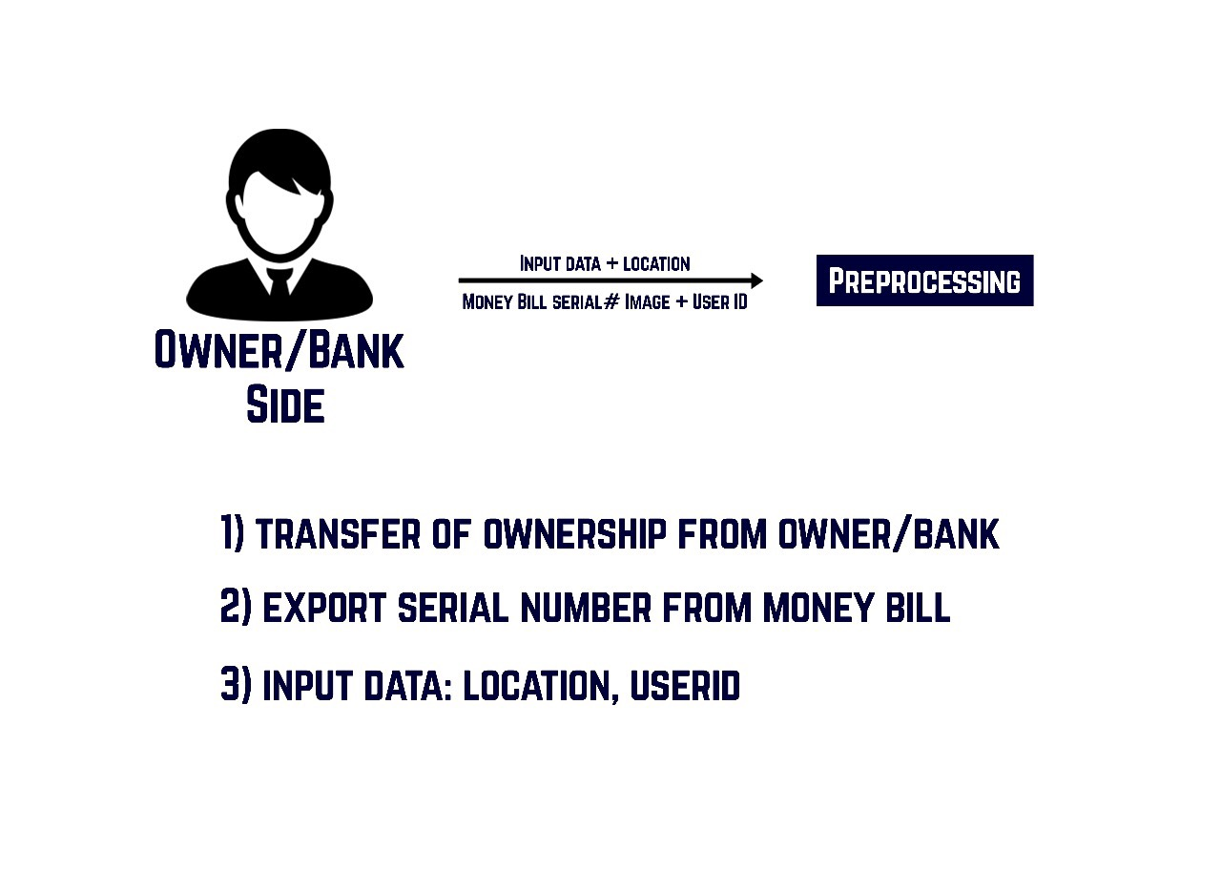
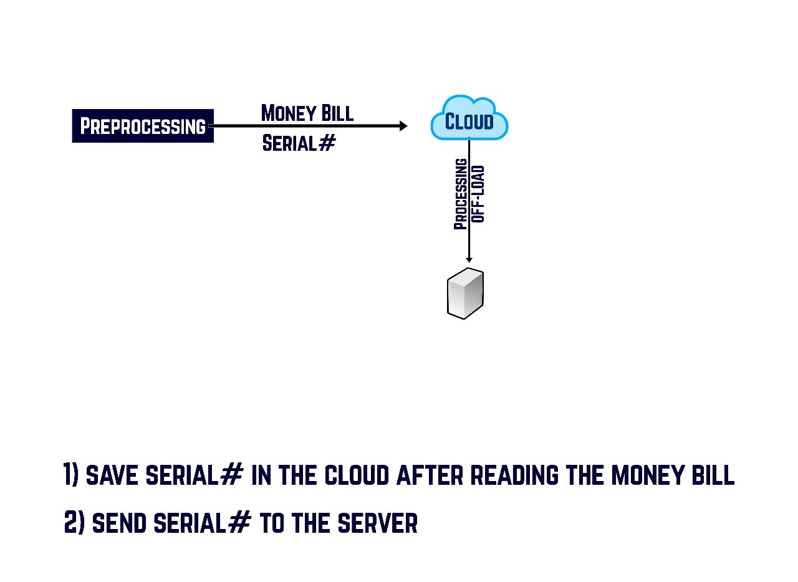

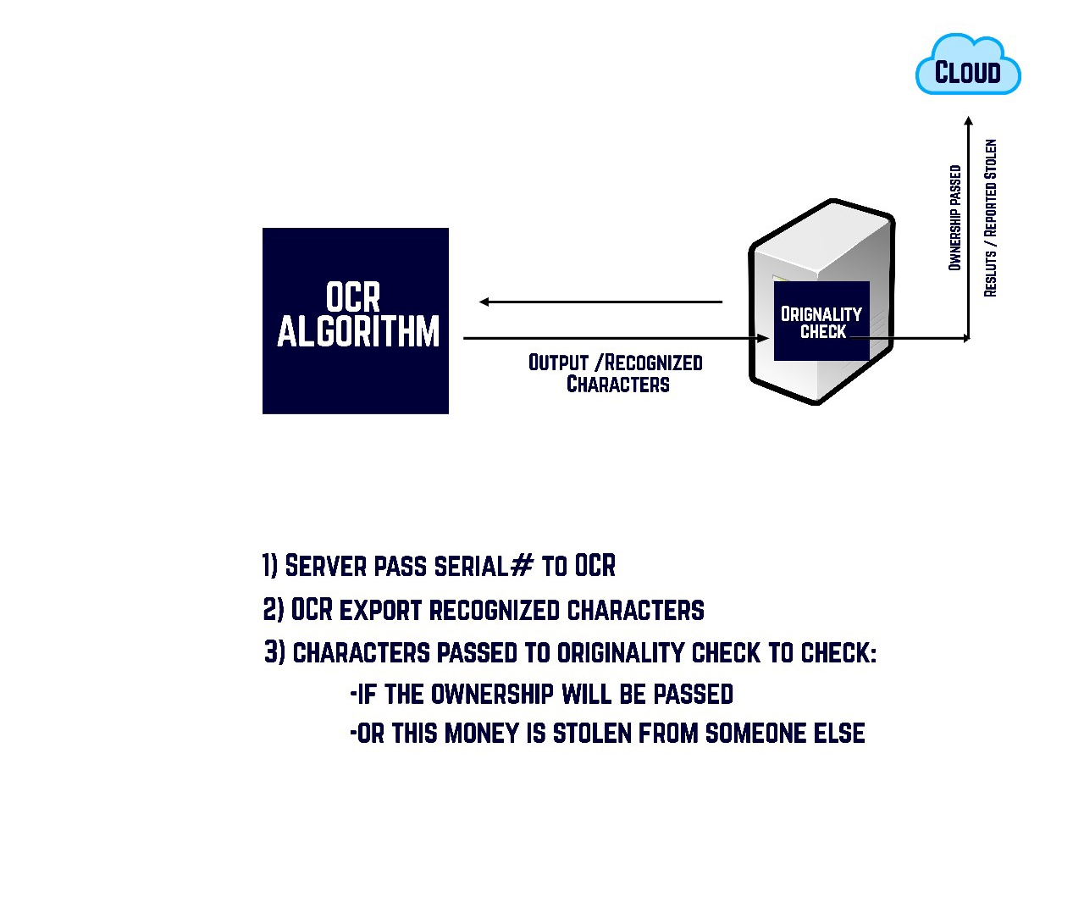

3 Similar System Information .

3.1 Similar System Description

Ashraf A. Shahin developed a technique to help recognize printed Arabic letters in a more efficient way.
Arabic script is a cursive script so they are represented through lines and curves.
The recognition technique Ashraf proposed, identifies each group of characters by their code.
A code is the characteristics that define Arabic letters. Arabic letters are characterized by lines, ellipses and points.
Using OpenCv to implement linear and ellipse regression, the technique had recognition rates 86% in Tahoma font and 83% in Times New Roman.
In the first stage, preprocessing stage, the text image is thinned using zahng-suen algorithm for thinning and then segmented into disconnected subwords.
Second, a code is generated for each character using the proposed technique and then compared to the word’s original code (codebook) for matching and recognizing the words, the. The words are introduced

3.2 Comparison with Proposed Project
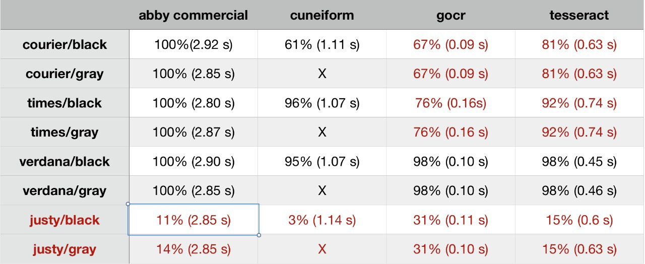

4 Project Management and Deliverable
4.1 Tasks and Time Plan
Task Name | Start Date | End Date
Proposal | 18/9/2017 | 26/9/2017
SRS | 27/9/2017 | 10/11/2017
SDD | 11/11/2017 | 17/1/2018
Implementing | 18/1/2018 | 7/5/2018
Validating and testing | 8/5/2018 | 25/6/2018
Final thesis | 26/6/2018 | 26/6/2018

4.2 Budget and Resource Costs
Item | Quantity | Cost
Sony projector MP1-CL1 | 1 | EGP7,199
Mobile | 1 | EGP10,000

References:

[1] anyOCR: A Sequence Learning Based OCR System for Unlabeled Historical Documents

[2] Secure Arabic Handwritten CAPTCHA Generation Using OCR Operations

[3] A Stroke Regeneration Method for Cleaning Rule-lines in Handwritten Document Images

[4] Multilingual OCR Research and Applications: An Overview

[5] Optical Character Recognition by Open Source OCR Tool Tesseract: A Case Study

[6] Optical Character Recognition (OCR) System for Roman Script & English Language using Artificial Neural Network (ANN) Classifier

[7] A novel OCR approach based on document layout analysis and text block classification.

