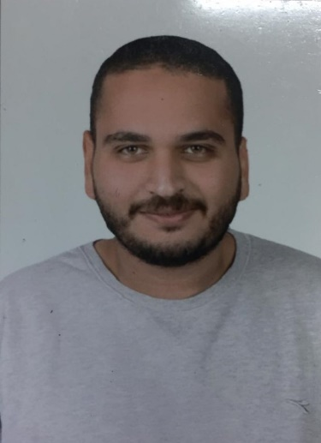 |  | Abdelrahman gamal tolba  Programmer Student
Objective  Seeking a position where I can maximize my management and program development experience.  CONTACT  PHONE:  01143896509  Birth Date:  22 August 1997.  EMAIL:  Abdelrahman1610437@miuegypt.edu.eg |  | EDUCATION  Misr International University  Faculty of Computer Science  Senior student – GPA 2.3 – 113 credit hours.  Talaa Islamic Languages School  Class – 2016  projects experience  Project  0ct. 2017 – Jan. 2018  Pharmacy Inventory system using java.  Project  0ct. 2017 – Jan. 2018  Amusement Park System using C++.  project  Feb. 2018 – Jun. 2018  Cash Memory Implementation ( LRU replacement in cash memory implementation using Java  project  Jul. 2018–Aug. 2018  System for flight booking using java.  project  Jul. 2018 – Sep. 2018  Chess game development specialized using java.  Project  Oct.2017-Jan2018  Chat sender and receiver using Python.  Project  Sep.2018-Jan2019  Pacman game problem using C++.  Project  Sep. 2018 – Jun. 2019  Real estate website development using (HTML,PHP,JQuery,Java Script and  MySQL).  Project  Feb. 2019 – Jun. 2019  Lebnon company for public transportation web application development using (HTML,PHP,JQuery,Java Script and  MySQL).  Project  Feb. 2019 – Jun. 2019  Huffman-encoding using python.  Project  Sep.2019-Jaunary2020  Fake news detection using python.  Project  Feb.2020-July2020  Proxy Server using python  Project  Feb.2020-July2020  STMP Server using python  Graduation Project  Sep.2019-July.2020  Fake tweets detection web application development using(Python,Html,PHP,MySQL)  Project  Website for Sinetest company using(PHP,HTML,MySQL)  technical skills  - Professional Java  - Professional Python  - Intermediate C++  - Professional HTML  - Professional PHP  - Professional Data Base Management
1

skills
- Professional Analytical thinking and problem solving
- Expert Communication skills
- Professional Microsoft Office
- Professional English language

