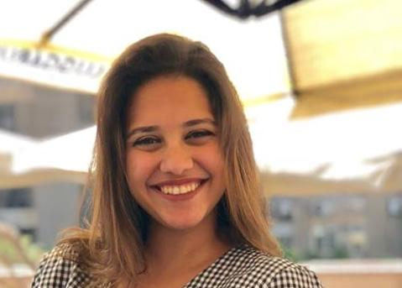 |  | MARIAM KHALED MOHAMED  Programmer Student
Objective  Seeking a position where I can maximize my management and program development experience.  CONTACT  PHONE:  01117799888  Birth Date:  25 June 1998.  EMAIL:  Mariam1604761@miuegypt.edu.eg |  | EDUCATION  Misr International University  Faculty of Computer Science  Junior student – GPA 2.56 – 109 credit hours.  Future Languages School  Class – 2016  projects experience  Project  0ct. 2017 – Jan. 2018  Inventory system using java.  project  Feb. 2018 – Jun. 2018  Cash Memory Implementation ( LRU replacement in cash memory implementation using Java  Project  Sep.2018-Jan2019  Pacman game problem using C++.  Project  Oct.2017-Jan2018  Chat sender and receiver using Python.  project  Sep. 2018 – Jun. 2019  Real estate website development using (HTML,PHP,JQuery,Java Script and  MySQL).  Project  Feb. 2019 – Jun. 2019  Lebnon company for public transportation web application development using (HTML,PHP,JQuery,Java Script and  MySQL).  Project  Feb. 2019 – Jun. 2019  Huffman-encoding using python.  Project  Sep.2019-Jaunary2020  Fake news detection using python.  Project  Sep.2019-Jaunary2020  Alumni mobile application using (Java,Firebase,XML)  Graduation Project  Sep.2019-July.2020  Fake tweets detection web application development using(Python,Html,PHP,MySQL)  technical skills

- Professional Java
- Professional Python
- Intermediate C++
- Professional HTML
- Intermediate PHP
- Professional Data Base Management

skills
- Professional Analytical thinking and problem solving
- Expert Communication skills
- Professional Microsoft Office
- Advanced written and spoken English language

